Assignment: CCNA

**Submitted By :- Purv Patel**

**Module -7: Network fundamental**

**Section 1: Multiple Choice**

1. Which of the following messages in the DHCP process are broadcasted?

A. Request

C. Discover

2. Which command would you use to ensure that an ACL does not block web-basedTCP traffic?

B. permit tcp any any eq 80

3. 3- R1, R2, R3, and R4 have their Fast Ethernet 0/0 interfaces attached to the sameVLAN. A network engineer has typed a configuration for each router by usingawordprocessor. He will later copy and paste the configuration into the routers. Examinethe following exhibit, which lists configuration for the four routers, as typedbythenetwork engineer. Assuming that all four routers can ping each other’s LANIPaddresses after the configuration has been applied, choose the routers that will beable to form a neighbor relationship with the other routers on the LAN. (Youcanassume that, if not shown in the exhibit, all other related parameters are still set totheir defaults.) (Choose two)

A. R1

B. R2

4-enable secret [password] ishashed using the _______ algorithm.

A. MD5

5- An engineer connects to Router R1 and issues a show ip ospf neighbor command. The status of neighbor 2.2.2.2 lists FULL/BDR. What does the BDR mean?

D. Router 2.2.2.2 is a backup designated router

6- Which command is used to view the neighbor discovery table on a PC?

D. netsh interface ipv6 show neighbors

7- What type of variable is being shown? Routers = [R1,R2,R3]

A. List

8- Identify the fields in an IPv4 header. (Choose three)

B. Dictionary

C. Simple

D. Unsigned integers

9- Host A and Host B sit in two different subnets. The path between the subnets of these two hosts runs through three different Layer 3 forwarding devices (routers andLayer 3 switches). A network engineer uses the APIC-EM Path Trace ACL Analysis tool to analyze the path used for Host A to send packets to Host B. Which part of thefunction is done specifically by the ACL Analysis or ACL Trace part of the tool?

D. Analysis of the impact of ACLs on the packets that would flow from Host A to Host B

10- Which IPv6 address is the equivalent of the IPv4 interface loopback address 127.0.0.1?

A. ::1

11- Which command is used to apply an ACL to an interface?

B. ip access-group

12- Which command and mode will successfully configure a hostname of R1onaCisco IOS router?

C. Router(config)#hostname R1

12- Which command and mode will successfully configure a hostname of R1onaCisco IOS router?

C. Router(config)#hostname R1

13- Which of the following reserved IPv4 addresses has binary 0s in all of thehost bitpositions?

D. Network address

14- A Cisco Catalyst switch connects to what should be individual user PCs. Eachporthas the same port security configuration, configured as follows: interface range gigabitethernet 0/1 - 24 switchport mode access switchport port-security switchport port-security mac-address sticky Which of the following answers describe the result of the port security configurationcreated with these commands? (Choose two)

B. If a user connects a switch to the cable, prevents multiple devices fromsendingdata through the port.

C. Will allow any one device to connect to each port, and will save that device’s MACaddress into the startup-config

15- What is the Administrative Distance of internal EIGRP routes?  
B. 90

16- When a subnet mask is presented in binary, what do the binary 1s represent?

A. The network portion of an associated address

17- Which switch would STP choose to become the root bridge in the selectionprocess?

A. 32768: 11-22-33-44-55-66

18- Which of the following devices is used by the service provider to provideWANservices?

D. CSU/DSU

19- Your Cisco IOS router isacting as a DHCP server. Which command will display the addresses that have been handed out to clients onthe LAN?

D. show ip dhcp bindings

20- Which of the following commands would you use to enable EIGRP only onthoseinterfaces with an IP address from 10.1.1.0 through 10.1.1.63?

A. network 10.1.1.0 0.0.0.63

21. What command could you use to have R3 advertise an OSPFv3 default route to the internal network?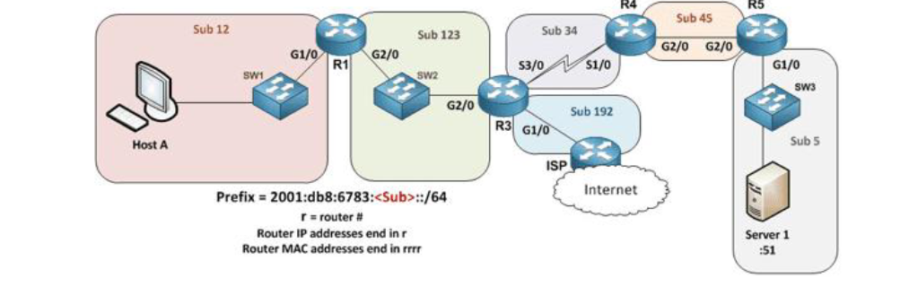

E. Have R3 use the command default-information originate always in OSPFv3 router configuration mode.

22- You are configuring dynamic NAT on your Cisco IOS router. Which commandisused to verify the interfaces that are being used as the outside interface andtheinside interface?

F. show ip nat statistics

23. When using the “show EtherChannel summary” command, what does the “u” flag signify?

D. Unsuitable for bundling

24. Which command could you enter to encrypt passwords?

C. service password-encryption

25. Which command is used to identify the IPv4 addresses that will be in the DHCP pool when setting up a Cisco IOS router as a DHCP server?

A. network

26. Which of the following statements are true regarding the processing of ACLs that have been applied to router interfaces? (Choose two)

A. Inbound ACLs will be processed before the routing table lookup occurs

C. Outbound ACLs will be processed after the routing table lookup has occurred

27. Which of the following answers list a condition that could keep the routers in your lab from learning all the routes to all the IPv4 routes in your small lab network? (Choose two)

A. An ACL could be blocking router advertisements.

C. Any physical layer problem that would prevent two neighbouring routers from being able to ping each other's IPv4 addresses in the subnet that exists between the two routers.

28. Which statements describe neighbour discovery functionality in IPv6? (Choose two)

A. Determines the link layer address of a neighbour

D. Queries for duplicate addresses

29. Which IPv6 prefix will the typical enterprise network receive from the service provider?

E. /48

30. How should a switch be configured so that it could be accessed remotely?

C. Configure a gateway for the switch

31. What conclusions can be made about the design with all hosts configured in the same VLAN?

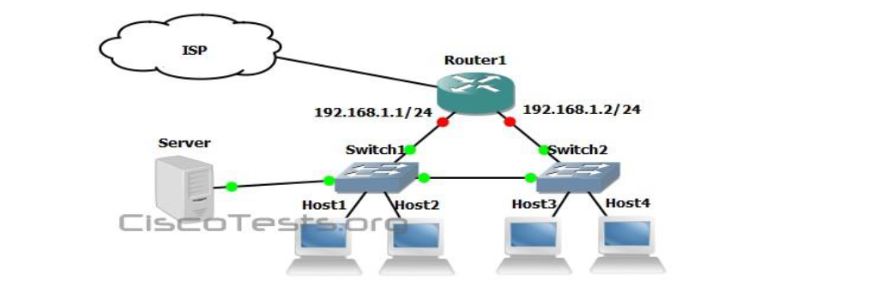

B. Spanning-tree will need to be used.

D. The connection between switches should be a trunk